Lab-Protein Basics

Xiaoxu Na

Q1. 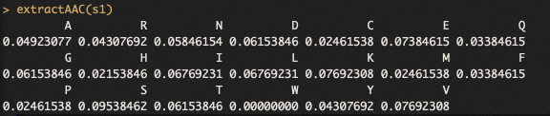

Q2

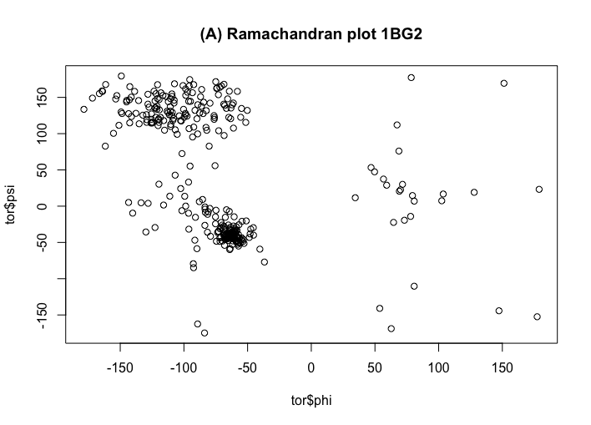

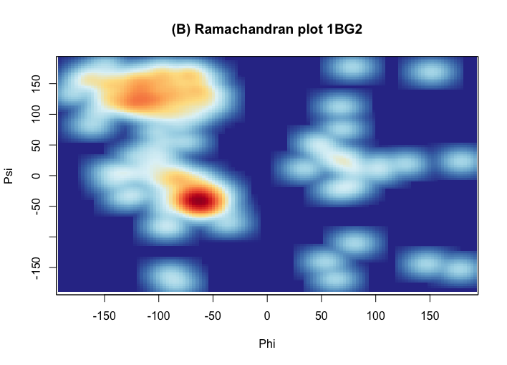

That is an Alpha and Beta protein since the psi and phi is distributed in both upper left and lower left regions of the Ramachandran plot.